**ARMS 7th Grade Common Formative Assessment – February**

1. Which change is most often caused by overgrazing in drought-stricken areas?
2. acculturation
3. desertification
4. urbanization
5. deforestation
6. Which phrase best explains Nelson Mandela’s goal?

Our struggle has reached a decisive moment. We call on our people to seize this moment so that the process towards democracy is rapid and uninterrupted. We have waited too long for our freedom. We can no longer wait. Now is the time to intensify the struggle on all fronts. To relax our efforts now would be a mistake which generations to come will not be able to forgive.

-Nelson Mandela, quoting himself from his 1964 trial upon his release from prison in 1990.

a. to end apartheid

b. to declare independence

c. to reverse constitutional reforms

d. to release key political prisoners

1. Dividing up Africa among European countries was the goal of the
2. Treaty of Paris
3. Balfour Declaration
4. Berlin Conference
5. Treaty of Versailles
6. For which major accomplishment is Nelson Mandela best known?
7. achieving racial equality
8. fighting for female suffrage
9. protesting for religious freedom
10. seeking safer work conditions
11. Who negotiated with F.W. de Klerk to end a racially divided social and political system in sub-Saharan Africa in the early 1990s?
12. Kofi Annan
13. Jimmy Carter
14. Desmond Tutu
15. Nelson Mandela
16. The excerpt below is from a 1961 US government document.

Pan –African is a mystical concept, glorifying racial kinship and the African personality and culture.

Which statement best describes the impact of this concept in Africa?

1. It led to the creation of an organization to create jobs in Africa.
2. It led to the beginning of a social movement to unify African countries.
3. It contributed to the creation of countries with a variety of governing systems.
4. It contributed to the founding of countries with governments based on democracy
5. The excerpt below is from a U.S. Department of State publication.

Between 1945 and 1960, three dozen new states…. achieved…outright independence from their …. colonial rulers. There was no one process of decolonization. In some areas, it was peaceful and orderly. In many others, independence was achieved only after a [long, drawn-out] revolution. A few newly independent countries acquired stable governments almost immediately; others were ruled by dictators or military juntas, or endured long civil wars.

Where were many of the new countries established during the process described in this excerpt.

1. Africa
2. Australia
3. Eastern Europe
4. Caribbean Basin
5. Which action is Mandela referring to in this excerpt?

I was made, by the law, a criminal, not because of what I had done, but because of what I stood for…

-Nelson Mandela

1. exile from his homeland for committing acts of treason.
2. punishment for speaking out against an oppressive government.
3. cancellation of his license to practice law in Johannesburg
4. removal as the head of the African National Congress
5. Which describes the relationship between water pollution and irrigation in Africa?
6. Water is typically polluted because of poor irrigation practices.
7. Irrigation practices have nearly eliminated all water pollution issues.
8. As water pollution increases, irrigation with clean water becomes more important and more difficult.
9. Through irrigation, countries in Africa are able to separate clean water from polluted water.
10. As environmental problems increase in Africa, water pollution is a growing concern. Which is a direct consequence of water pollution?
11. Reduced amounts of drinking water
12. Increased in population
13. More deforestation
14. Decrease in government stability
15. Which describe the relationship between deforestation and poor soil in sub-Saharan Africa?
16. Poor soil causes farmers to clear land for new soil which increases deforestation.
17. Deforestation is increasing the amount of poor soil in Africa.
18. Poor soil is killing forests.
19. Deforestation means fewer people live in an area which leads to poor soil.
20. Because of poor soil in many parts of sub-Saharan Africa, people are constantly clearing land for agricultural purposes. This mostly contributes to which other environmental concern in Africa?
21. Air pollution
22. Deforestation
23. Overpopulation
24. Oil-Refining
25. Use the list below to answer the question.

* **Less useable soil**
* **Smaller lakes and rivers**
* **Greater potential for dust storms**
* **Increased conflict over land use in the Sahel**

Which is **MOST LIKELY** the cause of the events listed above?

1. Water pollution
2. Oil pollution
3. Overpopulation
4. Desertification
5. Desertification is having the largest impact on which region of Africa?
6. Sahel
7. Nile River Valley
8. Sahara
9. southern Africa
10. Which describes the effect of the Sahara on jobs in the region?
11. There are few agricultural opportunities.
12. Most inhabitants are farmers.
13. The desert provides mostly irrigation jobs.
14. Hunting is the primary occupation.
15. In Africa, countries in the tropical rainforest face which conflict?
16. feeding their population vs. holding legitimate, democratic elections
17. deforestation of the rainforest vs. desertification
18. preventing the spread of AIDS vs. storing and maintaining their over abundant food supply
19. preserving their endangered environment vs. making money from logging companies that cut destroy the rainforest.
20. Religious groups are different than ethnic groups because most religious groups
21. require a common ancestry
22. do not exist in Africa
23. are not dependent on ancestry
24. have more shared culture than ethnic groups
25. What religious tradition contributed to the development of culture in North Africa and is now one of the major religious in North Africa?
26. Islam
27. Christianity
28. Nature worship
29. Judaism
30. Which statement is true regarding the Arab, Ashanti, Bantu, and Swahili ethnic groups in Africa?
31. These groups are the most economically
32. There is a large amount of religious diversity among and within groups.
33. None of these groups are native to Africa.
34. All of the groups rely on the same environment for survival.
35. The term “Bantu” describes people who share a specific group of_______________.
36. governments
37. races
38. religions
39. languages
40. The cultures of North Sudan and South Sudan have been most influenced by which ethnic groups?
41. European and African
42. Asian and Pacific Islanders
43. Asian and African
44. Arab and African
45. What would MOST LIKELY happen to the standard of living in African countries if more efforts were taken to increase literacy rates?
46. It would decrease
47. It would not change
48. There is no relationship between the two.
49. It would increase.
50. Women have a higher literacy rate in Kenya than in Sudan. This is MOST LIKELY because
51. Kenya invests more in education for girls.
52. Sudan does not offer any education.
53. Kenyan women are taught at home than in schools.
54. Sudan focuses only on math education.
55. Many countries and groups around the world are willing to contribute to help reduce famine in Africa. What problem in Africa makes it difficult to get these contributions to the citizens of African countries?
56. government instability
57. anti-African feelings around the world
58. citizens do not want to accept the help
59. deforestation limits the transportation routes
60. What is the impact of government instability on combating AIDS in Africa?
61. No other countries are willing to help
62. Citizens receive better education on preventing AIDS from the government.
63. The instability is helping to bring more attention to AIDS prevention.
64. It is difficult to distribute resources appropriately.
65. Which resource has the MOST DIRECT impact on the population and development of Nigeria?
66. uranium
67. lumber
68. oil
69. diamonds
70. The modern day political boundaries, civil wars, and conflicts found in Africa can often be traced back to
71. European cooperation in the late 1800s.
72. Ancient African trading empires
73. Asian invasions in the 1800s
74. European partitioning and colonization
75. How did nationalism affect countries like South Africa, Nigeria, and Kenya in the 1900s?
76. Nationalism reduced conflicts within these countries.
77. It is prevented these countries from gaining independence.
78. It led to greater demand for independence.
79. European countries used it to further their colonization of these countries.
80. The statements in the list below describe which idea?

* Seeks to unify African citizens
* Tries to make African countries more independent
* Believes Africans across the continent share common bonds and connections

1. Apartheid
2. African Culture
3. The Pan-African movement
4. The European partitioning of Africa.
5. Which of these organizations evolved out of the Pan-Africa movement?
6. Commonwealth of Nations
7. United Nations
8. Africa Union
9. North Atlanta Treaty Organization
10. Which African colony had been the personal property of Leopold II from 1885 until 1908?
11. German East Africa
12. French West Africa
13. British East Africa
14. Belgian Congo
15. Why was the Kenya African Union formed in 1944?
16. To gain independence from Great Britain for Kenya
17. To achieve better working conditions for laborers
18. To improve educational opportunities in Kenya
19. To improve trade between Kenya and its neighbors
20. What was one of the challenges faced by Nigeria after it gained independence from Great Britain in 1960?
21. There were no natural resources in the country.
22. Nigeria was isolated from other parts of the world.
23. Nigeria’s population declined rapidly.
24. There was conflict between the different ethnic groups.
25. In 1884, the largest European powers met in Germany to decide how they would divide Africa among them. Through this cooperation they created new boundaries that dived Africa into 50 countries. How did the new boundaries impact the people already living in Africa?
26. The new boundaries caused confusion and conflict.
27. The new boundaries helped people get organized.
28. The new boundaries were supported by most Africans.
29. The new boundaries helped cross-cultural communication.
30. Which political party took power after the end of the apartheid government in South Africa?
31. The New National Party
32. The Democratic Alliance
33. The South African Communist Party
34. the African National Congress
35. What was Nelson Mandela’s attitude toward the people who had been responsible for the old government of South Africa?
36. Many of the old leaders were sent to jail on his orders.
37. He felt the different races needed to try to work together in the new government.
38. He turned the leaders over to the United Nations for punishment.
39. He tried to have all the old government officials to other countries.
40. Nigeria has the potential to have great wealth from their oil wealth. Why is the country still dependent on foreign aid and foreign supplies?
41. Religious conflict between the ethnic groups prohibits the production of resources.
42. Ethnic violence between the Hausa and Igbo prohibit the production of resources.
43. Corruption in the government prohibits the development of natural resources.
44. The inability to repay foreign loans prohibits the development of natural resources.
45. South Africa faces all of the following challenges today EXCEPT ______________________________.
46. the rapid spread of AIDS
47. poverty
48. rapid industrial growth
49. crime
50. The social policy of South Africa that denied blacks human rights was ____________________________.
51. civil rights
52. apartheid
53. suffragette
54. imperialism

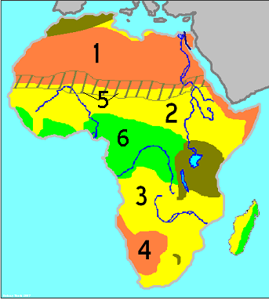

Which **landform** is located nearest number 1?

1. Kalahari Desert
2. Sahel
3. Sahara Desert
4. Atlas Mountains

41.

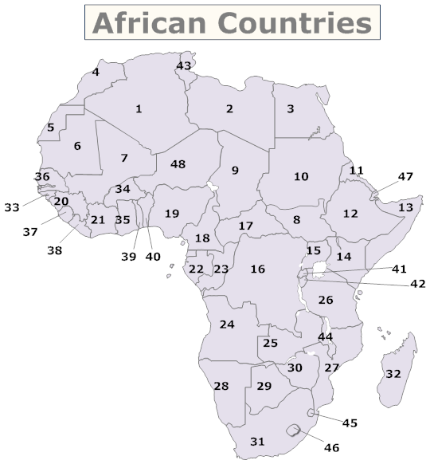

What number corresponds to number 10?

1. Somalia
2. Libya
3. Sudan
4. Kenya



Which number corresponds with South Africa?

1. 31
2. 1
3. 3
4. 4



Which **body of water** is nearest number 5?

1. Lake Tanganyika
2. Red Sea
3. Nile River
4. Niger River

44.



Which **landform** is located nearest number 5?

1. Sahara
2. Sahel
3. Rainforest
4. Atlas Mountains